**RESUME**

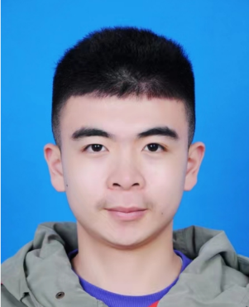

Yufei Xu

May 18, 2003

+86 18061192153

xuyufei11@sjtu.edu.cn

Shanghai

**Scholarship/Awards**

**2022.12 Shanghai Jiao Tong University**

"First-class Network Security" Scholarship

**2022.12 Shanghai Jiao Tong University**

Academic Year C Scholarship

**2023.03** **Shanghai Jiao Tong University**

Excellent Camper of the 20th "E Jun Training Camp"

**2023.01 Chinese Mathematical Society**

The 14th National College Students Mathematics Competition (non-mathematical) Second prize

**2022.12 Shanghai Mathematical Society**

The 14th Shanghai College Students Mathematics Competition Higher Education Club Cup (non-mathematical) Second prize

**EDUCATION**

**2021.09 – Present Time Shanghai Jiao Tong University Information Security**

**ABOUT ME**

Over the past two years, I have continuously strived to become a well-rounded and highly accomplished college student. Through my great efforts, I have excelled in courses such as physics, computer programming and so on, maintaining an average GPA of 3.79. I possess strong programming skills and problem-solving abilities. Additionally, I am actively involved in volunteer service, demonstrating excellent communication, leadership, and teamwork skills. Outside of my studies, I engage in physical activities, such as table tennis and swimming to maintain a healthy lifestyle.

I have a solid foundation in mathematics and physics as well as a strong research-oriented mindset, approaching tasks with composure. I exhibit a high level of enthusiasm in innovation, competitions, and various endeavors.

After careful consideration, I have chosen to continue studying and researching malicious traffic detection and vulnerability analysis under the guidance of my previous PRP mentor. This topic is crucial in both computer communications and financial transactions, and I aspire to make significant achievements in this field.

**Scientific research experience/competition**

Design and implementation of advanced hiding technology for malware (the 43rd PRP)

Mobile & IOT Security Lab

Information Security Works Competition

**Practice and volunteer experience**

Social practice of red memory (3 times)

Social practice of technology empowering traditional culture

Social practice of Yangtze River fishing ban survey

Volunteer for the 2022 Shanghai Marathon

Volunteer for the 2023 SPD Bank Shanghai Half Marathon

Volunteer for COVID-19 (286 hours)